Contents
Disclaimer 2
Introduction 3
Chapter 1 BlackJack Basic Strategy 4
Chapter 2 Card Counting 7
Chapter 3 Staking Systems 11
Chapter 4 The Anti-Martingale System and Blackjack 19
Chapter 5 The Importance of Position 24
Chapter 6 The Bonus Blunder 26
Chapter 7 Bonus Strategy #1 31
Chapter 8 Bonus Strategy #2 45
Chapter 9 Conclusions 52

Disclaimer

The publisher has aimed to be precise and comprehensive in the formation of this book. The publisher does not guarantee that the contents within are accurate due to the fast changing nature of online gambling.

While all efforts have been made to authenticate information included in this document, the publisher accepts no liability for errors, exclusions, or opposing interpretation of the subject matter herein.

In gambling strategy books, like everything else in life, there are no guarantees of income made. The reader is advised to be careful to apply their own judgment about their own personal situation to act accordingly.

Introduction
Successful gambling requires deliberate and conscious planning. In this context, the aim of any approach to gambling should be to stack the odds in your favour. While the casinos and bookmakers have designed the rules so that they can almost never lose. There is the occasional loophole. The aim of this book is to examine blackjack and define strategies that will help the player win.

We have heard of black jack players getting banned. This is, because it is beatable. In contrast, who has ever heard of a slots player, roulette player, a craps player or a baccarat player getting banned form a casino? The reason for this is that casinos are not in the business of banning players who are playing a game that is mathematically impossible to beat in the long term.

All profitable gambling systems are based on logic and/or statistical analysis. The ways that you can win are situations where:
- You can take advantage of loopholes when the odds favour of the punter OR
- There is a significant skill factor

In blackjack, there is both a skill factor and a loophole that you can take advantage of.

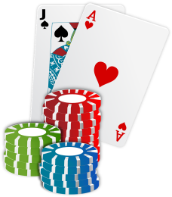
Chapter 1 BlackJack Basic Strategy
If you have been playing blackjack for any length of time, I am sure you will have heard of the “basic strategy”. In this chapter, we show tables showing basic black jack strategy.

The Basic Strategy
We will start by looking at the basic strategy. These include the following assumptions:
- At the beginning, the shoe consists of 4-8 decks
- The dealer will stand on a soft 17
- If you split, a double is allowed
- You lose your bet when dealer gets a blackjack

Table 1 Blackjack Basic Strategy
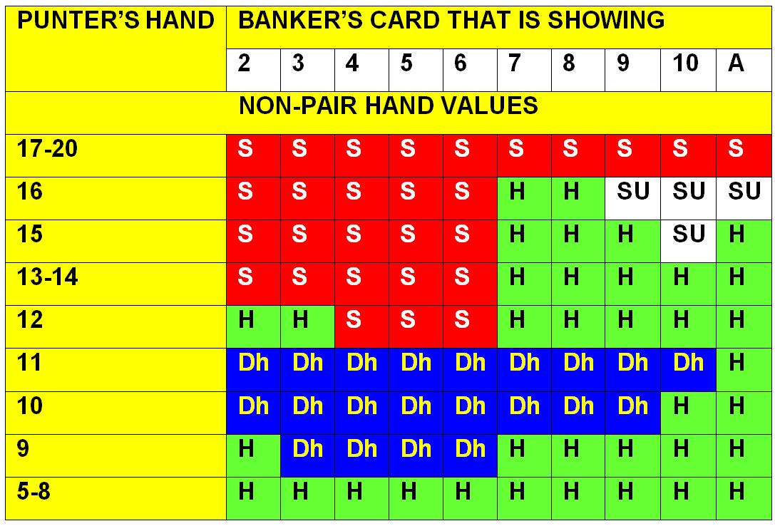
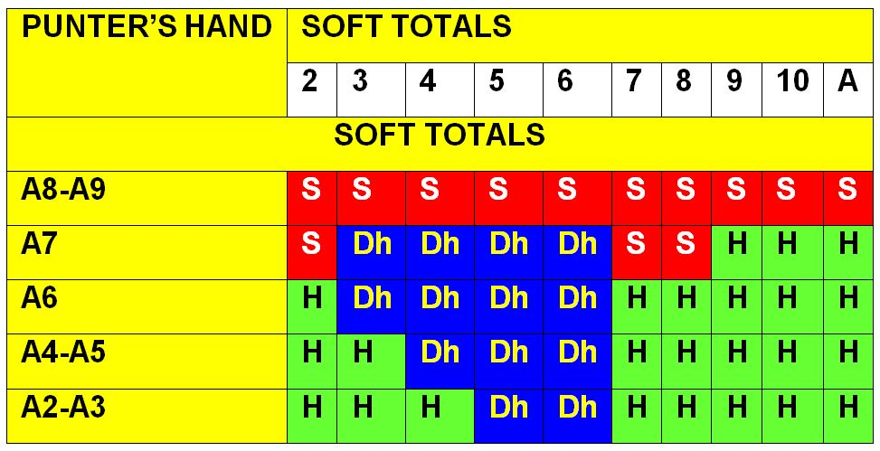
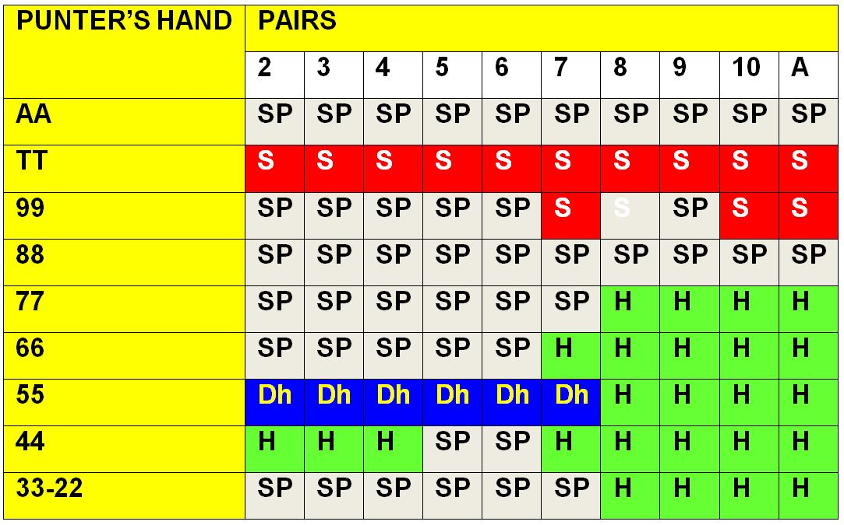
Key: S – Stand; H – Hit; Dh – Double but if not permitted, you should hit; Ds –Double but if not permitted, you should stand; SP – Split; SU – Surrender but if not permitted, you should hit

The house usually has an edge of between 0.5% and 1%. In terms of the house edge, this does make blackjack among the best value casino table games.

The casinos typically punish blackjack players when it comes to the cash out requirements for your bonus.

Many casinos require that you bet your deposit amount so many times that you are unlikely to be able to withdraw any of your bonus. In terms of probability, you will be likely to have lost all of your bonus before you get to the stage where you can withdraw your money. Other casinos offer bonuses for a number of games; however they exclude blackjack.

If you are a skilled blackjack player, many casinos are trying to stop you profiting from your enhanced skills.

Chapter 2 Card Counting
American mathematician Dr. Edward O. Thorp is believed to have invented card counting. His famous book Beat the Dealer (1962), revealed a range of betting and playing tactics to win at blackjack.

They aim of card counting is to reduce the casino’s edge by keeping a running count of high and low cards. This strategy enables card counters to bet more with decreased risk when the card count is in their favour. Furthermore, they can reduce losses when the count is favourable to the dealer.

These systems were mathematically correct. However, many of the methods are no longer useable. The casinos have taken counter-measures. For example, they don’t deal the last card anymore. Furthermore, the counting system known as the 10-count is not as profitable as point-count systems, that have subsequently been established.

The Fundamentals of Card Counting
The basic premise of card counting in blackjack is based on statistical evidence that high cards, such as aces and 10s, give the player an advantage. Conversely, low cards in the deck (eg 2s, 3s. 4s, 5s, and 6s) are disadvantageous to the punter.

Thus, a deck that is rich in aces and 10s increases the player's chance of hitting a natural Blackjack. This pays out 3:2 except when the dealer also has blackjack. Furthermore, when the deck is has a high concentration of 10s, the dealer is more likely to go bust. This is because the majority of blackjack rules require the dealer to hit stiff hands (12-16 total). However, the punter is allowed to hit or stand. For example, a dealer with cards totalling 12-16 will bust if the next card drawn is a 10. This is one reason why high cards help the player and low cards help the dealer.

Basic card counting systems
The most simple card counting confers a plus 1, minus 1, or zero value to each card. When a low card is seen, you add to the count. This is because they increase the percentage of high cards left in the shoe. Conversely, high cards reduce the count. The basic card counting system minuses one for each ten, Jack, Queen, King or Ace, while adding one for any value 2-6. Cards such as 7-9 have a value of zero and as such, do not impact on the count.

Online Systems
There are players who believe that card counting is possible in the online casinos. However, it is often unclear how often the casino shuffles.

Important: You must find a casino where the deck is not shuffled after each hand.

If you don’t know whether a casino shuffles the deck(s) after each hand, you must find out. None of the card-counting or staking systems will work at a casino where the deck is shuffled after each hand.

However, there are online casinos that just host blackjack games and you play against another player. In this context, the casino just gets a percentage of your stake. If you are more skilled than your opponent, you can win money. However, remember that you have to beat the casino’s commission before you can start making money.

Comment
Casinos hate losing money. Therefore, it is best to focus on games where the casino hosts a game between you and at least one other player. These types of games are skill games that are hosted by the casino but your opponents are real life players. In this context, the casino isn’t actually taking part in the game but it takes a commission and makes money whatever the result. Therefore, you have a chance to make money as well.

Chapter 3 Staking Systems
In this chapter, I will explain a staking system that can be used as an alternative to card counting. Although card counting is more accurate, it can make playing blackjack cumbersome.

If you go on the internet, you will find a bunch of blackjack staking systems that are not based on your cards or on a card count. They are simply based on the stake that you used in your previous hand.

Although mathematicians say such systems never work, we will think about one of these systems in a bit more detail.

The Martingale System
The Martingale System does not work for blackjack. However, I will briefly go over the Martingale System because it is the basis of a system that does make sense.

The Martingale System is often associated with roulette. However, many players have attempted to use the system as a blackjack system as well. There are several roulette systems based on the original martingale system. The most basic of these strategies was created for a 50: 50 paradigms. An example of such a situation is when you toss a coin. You have a 50% chance of getting heads or tails. Roulette players have also used the martingale strategy. The probability of hitting either red or black is just under to 50%.

I will explain how the system works in relation to roulette.

The player decides how much he wants to win. We will say that he aims to win $10. The punter bets $10 on red or black. Whatever colour he chooses, he sticks with it, until he has won $10.

If he wins, he bets $10 on the next bet on red or black.

If he loses, he doubles the previous bet. He bets $20. If he wins this bet, he has won the $10 that he wanted to win and therefore, he goes back to step 1. If he loses, he bets $40. The idea is that, if he wins, he will win the $10 that he lost back plus the $10 that he wanted to win in the first place $30 that he lost back plus
the $10 that he wanted to win in the first place.

Basically, the gambler continues doubling his bet until he wins his money back plus the $10 that he initially hopes to win.

The basic premise behind the martingale strategy is that a gambler will eventually win in roulette. The martingale betting strategy was seen as a safe betting strategy by those who employed it.

Does it work?
Absolutely NOT. It might work in the short term. However, there will eventually be a disastrous run which would leave the gambler bankrupt. In addition, there is the problem of casino betting limits preventing a player from doubling their bet indefinitely.

Why did it gain popularity?
The reason it gained popularity is because intuitively, you know that the roulette when cannot come up the same colour forever. There are 2 possible reasons why gamblers believe in this system.

They don’t realise how high their stake will have to rise in order to win and how often.
They think the roulette wheel has a memory.

In order that you understand how fast your bet can increase, look at Table 1

Table 1 The number of bets lost compared to the probability of losing this number of bets in the Martingale System.

Bet size | Number of bets lost | Probability of losing this many bets
$10 | 0 | 0
$20 | 1 | 1 in 2
$40 | 2 | 1 in 4
$80 | 3 | 1 in 8
$160 | 4 | 1 in 16
$320 | 5 | 1 in 32

Table 1 shows that 1 in 32 times, you will be betting $320 to win your $10 that you decided you must win. How do you feel about that?

Some gamblers think that if red came up last time on the roulette wheel, black should have a better chance on the next spin.

This is the so-called “Gambler’s Fallacy”. The Roulette Wheel does not have a memory.

The Anti-Martingale System
The anti-martingale staking system is also referred to as the reverse martingale. In the traditional martingale betting strategy, gamblers double their bets after each loss with the view that any future win will recoup all prior losses.
The anti-martingale tactic employs increased bets after wins, while reducing them after a loss. The opinion is that the punter will profit from a winning streak, while decreasing losses while on a losing streak. In games such as roulette and craps, individual bets are independent events, the idea of winning “streaks” is a fallacy. Consequently, the anti-martingale tactic for such games is unsuccessful.

Is the system good for any gambling?
In order for the system to be useful, you have to look for is a form of gambling where hot streaks are not random. However, it can be difficult to find uses for the system because bookmakers won’t often give you 50:50 odds on non-random events. A few ideas are listed below.

Trading
The system, however, might work as a trading system. When there is an economic upturn or downturn, it may be possible to employ this system. This is because the events that caused the changes in the markets are not random events.

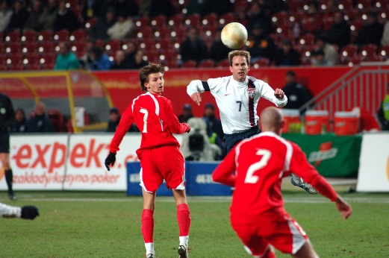
Football
When a team such as Chelsea or Manchester United hits a hot streak, the anti-martingale system may be useful. However, the odds may ruin the chances of it working.

Horse Racing
Some trainers train their horses to win a few races in a row. If you have an idea of who such trainers are, this system may prove useful. Again, the bookmakers’ odds may affect the chances of this working. An alternative strategy might be to lay horses when a trainer is running cold using this system.

The Anti-Martingale System in Heads-up Skill Games
The anti-martingale system may be particularly useful in heads-up skill games where the stake has been agreed before the game. We will look at backgammon as an example.

Backgammon
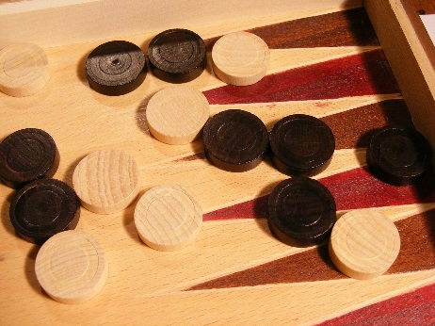
The dice are random in backgammon. However, if your opponent becomes demoralised when you are winning, you may gain an advantage. In addition, if you see that he is making mistakes because he has hit a cold streak, the anti-martingale system might work. This would work best in match play as opposed to money games. The reason for this is that the total stake is decided before the game in a match.

Nevertheless, the strategy may be useful in any skill game when your opponent is demoralised and wants to chase his losses.

Other skill games where the system might work include
- Dominoes
- Gin Rummy
- Spades
- Yahtzee
- Heads-up blackjack
- Heads- up poker

Conclusions
The anti-martingale strategy may be useful in any skill game when your opponent appears to have become demoralised. Frequently, becoming demoralised can lead a player into making mistakes. Furthermore, your demoralised, mistake-making opponent may want to increase the stakes in order to get his money back. If you are in are facing such an opponent, you should consider accepting an offer of an increase in stakes. However, only consider it if you are sure that the increase in stake is not going to affect you psychologically. You don’t want to end up playing a skill game badly because you are scared of the increased stakes.

However, if you have become demoralised, you should never increase the stakes. According to the anti-martingale strategy, you should actually reduce your stake.

Chapter 4 The Anti-Martingale System and Blackjack
As it is possible to win at blackjack by card-counting, wins at blackjack cannot be said to be totally random events. In roulette, a win has no influence on whether a player will win on the next spin.

In blackjack, some wins will be random, while other wins will be because the card count is in the player’s favour. If you assume that the card count is in your favour when you win a hand, you can increase your stake to double the original stake on the next hand.

The important thing to note is that this will be more profitable than randomly betting more on a certain percentage of hands. Therefore, after a win, I am proposing that you double your stake and stay at this doubled stake until you lose. At this point, you should return to your original stake.

For example, let’s say that you bet $10 on a normal hand. After a win, you increase your stake to $20. You stay at $20 until you lose a hand. Note that this system differs from the anti-martingale system. The anti-martingale system involves increasing your stake over and over again until you lose. My system only involves one double up of your stake.

Refining the System
Let’s try to add a small amount of card counting to the system.

The basic card counting system minuses one for each ten, Jack, Queen, King or Ace, while adding one for any value 2-6.

Cards such as 7-9 have a value of zero and as such, do not impact on the count. We will start counting from the winning hand.

If the count goes up, stays even or down by one, we will double up. If the count goes down by more than one, we will not double up. Therefore, you do need to be attentive to the count on each hand. However, you don’t need to carry over the count to the next hand.

We will never bet more than double our initial stake

Hand 1
Punter’s Hand
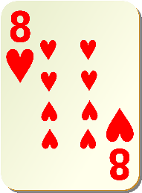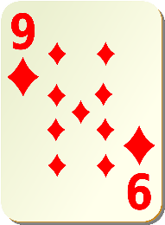

Dealer’s Hand Dealer hits twice and busts
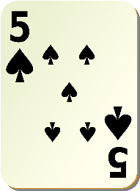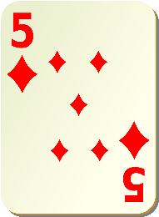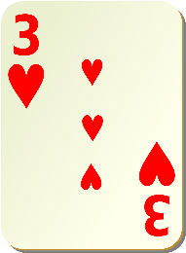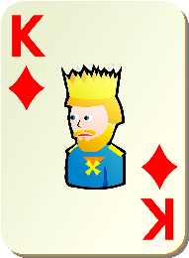

In this example, you win the hand and the count has gone up by 2.
You add 1 for each 5 in the dealer’s hand (+2)
You add 1 for the 3 of hearts (+1)
You subtract 1 for the king of diamonds (-1)
The 8 and the 9 in punter’s hand counts as zero.
If you were playing at the initial stake, you can double your stake on the next round.
If you are already playing at double the initial stake, you should just stay at this stake.
We never go above double the initial stake.

Hand 2
Punter’s Hand
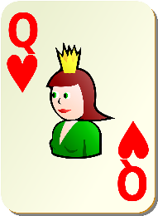

Dealer’s Hand Dealer hits and busts
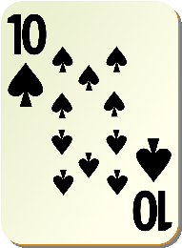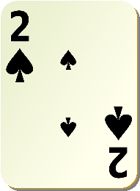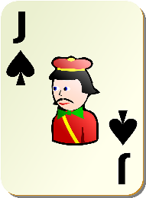

In this example, you win the hand. However, the count has gone down by 3.
You add 1 for the 2 of spades (+1)
You subtract 1 for each of the other 4 cards (-4)
If you were playing at the initial stake, you should stay at the same stake on the next round.
If you are already playing at double the initial stake, you should go back down to the initial stake.

Therefore, the rules for the system are.
  - After a loss, play at the initial stake
  - After a win, play at double the initial stake if the count on the last hand was -1, 0 or +1 or more
  - After a win, play at the initial stake if the count on the last hand was -2 or less
Remember, that you never play above the initial stake.

Chapter 5 The Importance of Position
When there are several players at a table, position is important when using this system. Ideally, you should be in the last place before the dealer. The later your position, the better.

If you are simply playing the basic strategy, without card counting, position at the table does not have an influence. However, when you are card counting, you get more information on the cards that have gone when you are on the dealer’s right. The closer to the dealer’s right you are, the better position that you have.

For example, let’s look at the following hand.

Hand 3
Punter’s Hand
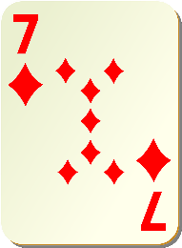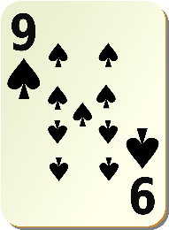
Dealer’s Hand
Let’s say punter won the last hand and the count was -1. There are several other players at the table and punter is directly to the right of the dealer. If punter has seen a lot of high cards and few low cards in the other players’ hands, the count will have dropped further.

In this situation, punter might opt to hit and see if he can get closer to 21. Punter’s decision should depend on how far the count has dropped. It depends how far the count has dropped.

When using the system used in this book, you should just stick to the basic strategy. This is because our card counting system is an approximation. We are assuming that at least, a proportion of your wins will be due to the card count being in your favour. However, there will also be a proportion of wins that occur by chance. You should always be aware that your last win might have been by chance and therefore, the count will not be real.

However, if you are keeping a running count, a good position provides more up to date information as to what the count is.

Chapter 6 The Bonus Blunder
If you are signing up to a new casino, they usually require that you deposit some money before you can get a welcome bonus. In general, you have to bet the amount in your bonus a certain number of times before you are allowed to cash out the bonus. The amount of times that you have to stake your bonus can vary from game to game and casino to casino.

Bonuses are an essential consideration to a gambler because every small amount of money counts when you are trying to become a winner. Many players think that the gambling is just about winning big. Obviously, this is important. In addition, avoiding losing large amounts is an essential skill as well.

However, once you appreciate how the games work, you will understand that a lot of the money is about winning little amounts of money frequently. If you want success in gambling, following the motto, “look after the pennies and the pounds looking after themselves”. This will get you far.

Loyalty to Casinos is a Losing Strategy
When a casino site or a casino offers you a bonus, they are hoping on you staying a loyal customer. While loyalty is an admirable personality feature in normal social life, it doesn’t make sense to be loyal to a business who really just wants your money.

What to do once your bonus is cleared
Once your bonus is cleared, you should cash out and move onto the next casino site and get another bonus. The only exception to this rule is if the original casino offers you another bonus. There are so many companies hosting blackjack that it will take a long time before you will run out of opportunities to get a bonus. When you stay away from a casino after your bonus has cleared, they will frequently offer you another bonus to get you back as a customer.

The Bonus Release Calculator
On the Casino Octopus website, we provide a free bonus calculator. Using this calculator, you can work out whether you will win or lose money by the time you have met the bonus withdrawal criteria.
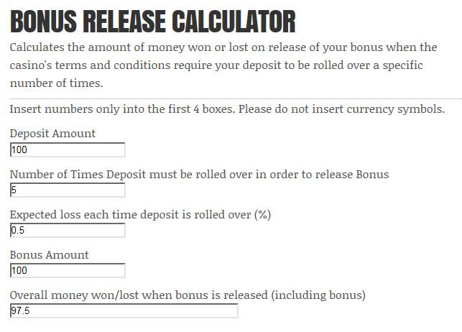
This calculator is to determine how much money you will have won or lost on a game of chance once you are allowed to cash out your bonus.

The calculator assumes that you have to rollover your deposit a specific number of times in order to be able to cashout your bonus.

How to use the Calculator
- Insert the amount of money you have deposited in order to qualify for your bonus into the box labeled “Deposit Amount”.
In this example, we have deposited $100. We don’t put the currency symbol in. We just put the numerical amount in.
- Insert the number of times that you need to bet your deposit (or roll your deposit over) in order to be allowed to cash out your bonus.
In this example, we have to bet our bonus amount 5 times before we can withdraw, what is left, of our bonus.
- Insert the percentage of money that you expect to lose each time your deposit is rolled over. Express this as a percentage. Therefore, if you expect to lose 5%, just insert the number “5”. If you expect to lose ½%, insert the number “0.5”.
For this example, we expect to lose 0.5% of our money each time we bet.
- In the box labeled as “Bonus Amount”, you insert the amount of bonus money given to you by the casino.
In the example, we have used the amount of $100.
- In the last box “Overall money won/lost when bonus is released (including bonus)” a number will appear. It is the amount of money you will have won or lost INCLUDING your bonus at the point when you are allowed to cashout your bonus.
As you can see in the example, you can expect to withdraw $97.5 of your bonus money.

When online gambling first started, the bonuses that casinos offered were very generous.

If you look at blackjack bonuses, you will see that you will usually lose money by the time that you get to cashout your bonus.

THE #1 MISTAKE THAT NEW PLAYERS MAKE IS SIGNING UP FOR BLACKJACK BONUSES

THE #2 MISTAKE THAT NEW PLAYERS MAKE IS SIGNING UP TO THE BIG BLACKJACK SITES

Those big flashing bonuses at the big sites may look great. However, if you are starting at low stakes, it will take you a long time to get any significant bonus money. That’s if the bonus doesn’t have an expiry date. If the bonus has an expiry date, you have virtually no chance of getting a significant amount of that money released.

If you look at the terms and conditions of most of these bonuses, you will lose more than you get back as a bonus in most instances.

So, you got your bonus (or at least some of it) but you are still down in terms of money.

IT DOESN’T HAVE TO BE THAT WAY !!!

In the next chapters, we will look at alternate ways to get bonuses.

Chapter 7 Bonus Strategy #1
The Giant Loophole - How to get a free $1000
This is a potent system of getting effortless free money to start your gambling career. Not all players from all countries are eligible for free money using this system. Punters from the UK and Ireland definitely can get this money. Furthermore, players from several European countries and Canada are able to get some of this free money too.

If you are not eligible for these bonuses, don’t worry!
I have another way that you can get money to play blackjack in the next chapter

Even if you play other casino games, you must read this
You can use this money to fund any game you want.

For example, let’s say you want to play blackjack. You should use this system to get the money to play blackjack.

Most players start playing blackjack at the big casino sites. The sites offer you a bonus and you have to play a certain number of games, matches or hands to release the bonus. Some of these bonuses are have a time limit. For example, you might get something like 90 days to release your bonus. In your efforts to get your bonus, you have probably paid as much or more in rake or commission. If you are just learning a new game, you may have even lost cash in your efforts to release your bonus. The result may be that, you obtained your bonus and got yourself into a position where you can cash out (at least some of it). However, you have still lost money.

In this chapter, I will explain how players from some countries can have their favourite game staked without using their own money. You will require at least $50 to start obtaining this money. However, this money is at almost no risk.

There are a lot of bookmakers who host blackjack. Virtually all of them offer bonuses.

The last thing you should do is sign up for these bonuses

This is what you should do
Sign up to these bookmakers through the sportsbook!!!

Matched betting
Matched betting (also known as risk free betting) is a mathematical method of winning money. Basically, you sign up to a casino or bookmaker via the sportsbook. You will be offered a welcome bonus. You will learn how to release and withdraw this bonus or, at least, a part of it. You do this by betting at the bookmaker and betting against your bet at a betting exchange. These terms will be explained if you are new to them.

There are more than 100 bookmakers where UK and Ireland residents obtain welcome bonuses. They don’t all offer skill games. However, there is no rule to prevent you from releasing your sportsbook bonus and moving the money to a bookmaker that does host skill games. When you register at a bookmaker to play a skill game, you shouldn’t forget to enter through the sportsbook page. You may as well collect another welcome bonus.

What is Matched betting?
When you sign up to a bookmaker through the Sportsbook page, you are presented with an offer of a welcome bonus. Matched betting is a system of almost guaranteeing that you will be able to withdraw most of the bonus. Once you have satisfied the withdrawal requirements, you can use this money to play any skill game. Actually, you can use this money how you wish, including simply putting it into your bank account.

You will need to open an account at a bookmaker and a betting exchange. You should sign up to as many betting exchanges as you can because they also offer welcome bonuses as well. In the examples in this chapter, I will use Betfair as the betting exchange.

What is a Lay Bet?
When you place a lay bet you are betting against another customer's stake who thinks that a particular result will happen. If the result does occur you have to pay the other client at the odds that you agreed on. In contrast, if the outcome does not occur, you win the other client‘s stake.

For example, let's suppose that Arsenal playing Real Madrid. We don't think Real Madrid will win so we lay Real Madrid for £20 on Betfair at odds of 1.80. This means that we accept a £20 bet from another client of Betfair. If Real Madrid win, we will have to pay the Betfair customer £16 (in addition, they get to keep their £10 stake). Conversely, if Real Madrid lose, we keep the £20 stake. By laying Real Madrid, we win if Arsenal win or draw.

How does Matched Betting Work?
The majority of bookmakers have a requirement that you have to make at least one bet, before they will release your free bet. At the time of creating this chapter, Coral is offering a “Bet £5 Get £20 Free Bet”. This means that you have to bet £5 and this will release a free £20 bet. The original £5 bet is referred to as the “Qualifying Bet” and the £20 bet is called the “Risk Free Bet”.

The bonuses, offered by bookmakers, and terms and conditions can alter from time to time. Although the examples that I am using to illustrate matched betting are accurate at the time of writing, you must always verify the terms and conditions for:
- What is the bonus amount?
- Is the bonus stake included in the winnings or do you just obtain the winnings resulting from the free bet?
- Is the bonus offered in your country that you live in?
- Is there a date of expiry date for your welcome bonus?
- What odds, are you permitted to bet at, for the free bet to be released?
- What odds, are allowed to bet at, for the free bet to be valid?
- What requirements do you have to meet to withdraw your winnings associated with your welcome bonus?

Betting Exchanges
There are several betting exchanges, such as Betfair and Betdaq.
The betting exchanges offer welcome bonuses too !!!
Traditional bookmakers differ from betting exchanges. A conventional bookmaker permits you to bet on a specific outcome. However, they do not allow you to lay a bet. In contrast, a betting exchange allows you to bet on and outcome and to lay a bet.

You will now learn how the lay bet helps to extract the bookmakers’ bonuses

The Qualifying Bet releases the Free Bet
This is how it works. Let’s take an example of Liverpool playing against Tottenham Hotspur.

You will bet £5 on Liverpool to win at the bookmaker. Next, you will go to a betting exchange and “lay” Liverpool. A lay bet means that you are accepting a bet from a punter who wants to bet on Liverpool. This effectively means that you are betting on Liverpool to win at the bookmaker and Liverpool, while simultaneously betting on them to lose at the betting exchange. If Liverpool wins the match, you will win your bet at the bookmaker and you lose your bet at the betting exchange. If Liverpool loses, you will lose your bet at the bookmaker and you win your bet at the betting exchange.

The overall result is that you will have a small loss between the 2 bets. However, this will release of your £20 free bet.

Summary of the Qualifying Bet
- We place a qualifying bet at the bookmaker (this will release the free bet)
- We lay the bet at the Betting Exchange (ie we bet against the result that we have bet on at bookmaker). The plan is to lose the smallest amount possible of the £5 qualifying bet.

At the time of writing, the best place to begin your matched betting career is at Coral. The reason for this is that you only need to wager a £5 qualifying bet in order to release your free bet. You then need to wager your free bet to be able to cashout your winnings.

Worked Example of the Qualifying Bet

The Bonus Terms: Bet £5 and receive a £20 FREE BET

How it works
In order to get our bonus money from Corals, there are 2 sets of bets required

Step 1 The Qualifying Bet
- We will place a £5 qualifying bet at Coral (this will release the free bet)
- We will lay the bet at Betfair (ie we bet against the result that we have bet on at Corals).
The aim in step 1 is to lose as little as possible of the £5 qualifying bet.

Step 2 The Free Bet (Stake is not returned)
- We then bet our free bet at Corals.
- We lay the bet at Betfair.

Our bet will be sized in order to make a profit whether we win at Corals or Betfair

Qualifying Bet
Step 1 Place our qualifying bet.
In order to reduce our loss on the qualifying bet we need to find a bet where the odds at Corals are very close to the odds at Betfair.

This occurs more frequently with shorter priced bets. As such, we will look for a short priced favorite. You should have all your odds calculated as decimals. If the odds appear in fractions, all bookmakers and betting exchanges have a link where you can switch to a decimal format. At Coral, you should click on the link in the top menu (see the red arrow below).

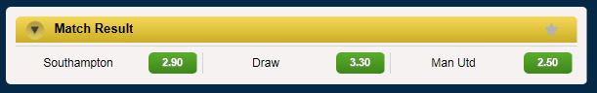

We are considering betting on Manchester Utd to win. It doesn’t matter what team you choose. However, you don’t want the odds to be too large. Otherwise, you will require more money to cover the bet at the betting exchange when you lay your bet.

For the second step, we will go to Betfair. At Betfair, you should make sure you are at the exchange and NOT the sportsbook. The reason for this is that you can lay Manchester Utd at the exchange.

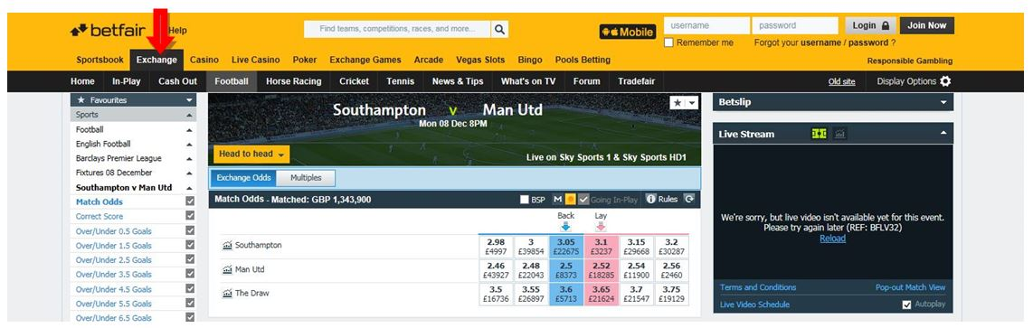

We want to place our qualifying bet on Man Utd to win at Coral at 2.5. When selcting a bet, you should aim to find a bet where the odds at the bookmaker are close to the odds at the exchange. In this example, Man Utd is an excellent bet because the odds at Coral are 2.5 and the best lay odds at the exchange are 2.52.

We now need to calculate how much we need to lay at Betfair. To do this, you should go to the menu at Casino Octopus and click on the link “Matched Betting Calculators”.
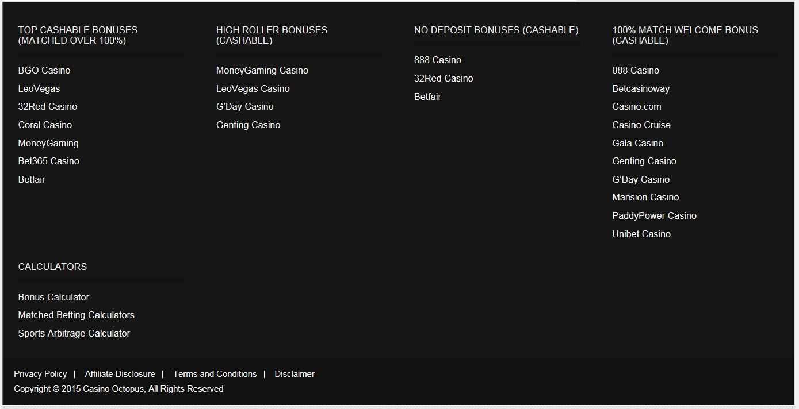
When you scroll down, you will see the Casino Octopus Matched Betting Calculator. You need to make sure that the “Qualifying Bet” button is clicked.

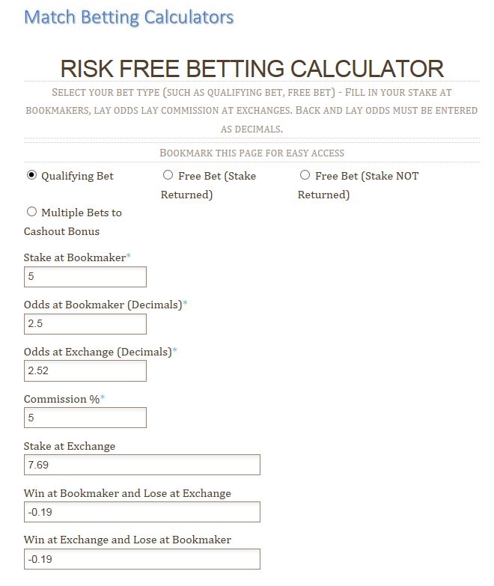
Now, you need to inset the information in the top 4 boxes.
- Your stake at the bookmaker (this is £5 in the present example)
- The odds at the bookmaker (2.5 in the present example)
- The odds at the exchange (2.52 in the present example)
- The commission that you must to pay at the betting exchange (5% in the current example). You should read the terms and conditions to find out the commission at the exchange. At the time I am writing, the commission at Betfair is 5%.
Once you input this information in, the amount you are required to bet at the exchange will be displayed in the box “Stake at Exchange”. In the lowest 2 boxes, the amount of money you will lose from this bet is displayed. The result of the 2 bets is a loss of £0.19 whether you win at the bookmaker or the exchange. This loss is tiny when you consider that this results in the release of a £20 free bet.

The Free Bet (Stake NOT Returned)
Step 1 Place our free bet.
As in the qualifying bet, in order to reduce our loss on the qualifying bet we need to find a bet where the odds at Corals are very close to the odds at Betfair.

As already noted, this occurs more frequently with shorter priced bets. Therefore, we will look for a short priced favorite. Make sure that you have all your odds calculated as decimals.

We will start at Coral. The odds on Southampton are 2.45.

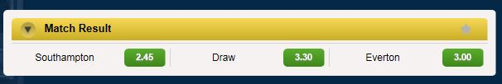

At Betfair, the lay odds are 2.56. This isn’t a great price between the bookmaker and the betting exchange. I haven’t looked too hard for a great example. This is because, we can still make a nice profit.

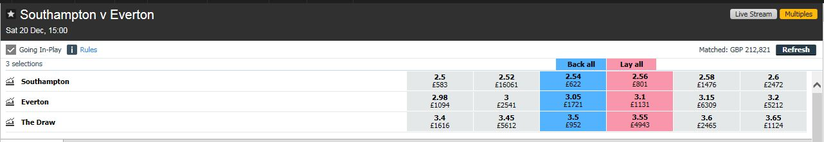

The stake is not returned. You go to the matched bet calculators at Casino Octopus. Therefore, remember to check the “Free Bet Stake not Returned” button.

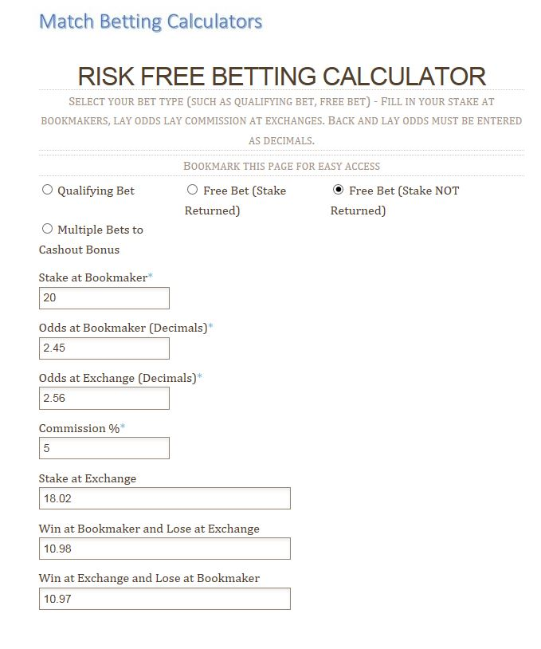
You input the stake, odds in decimals and the commission at the Betfair. You bet your £20 free bet at Coral and £18.02 at Betfair. The result is that you will collect £10.97 at least. That will be your profit!!!

This is what happened. You lost £0.19 on your qualifying bet and you gained £10.97 with your free bet. The result is that you have won £10.79.

Most offer even bigger bonuses than Coral. However, Coral offer a great ratio of deposit: free bet. Your £5 gets you a £20 free bet. I recommend starting at Coral because you get a good ratio between the qualifying bet and the free bet and because you don’t need much money to cover your bets.

There are 100 bookmakers that UK and Ireland players have access to. Can you see how you can make over £1000 using this system? This is a complete no-brainer. I can’t imagine you will ever find a system, where no skill is involved, where you can collect so much money and so easily.

Comment
If you are serious about gambling like a pro, you should collect this money. There will come a point where you run out of bookmakers bonuses. However, you should plan to use this money to develop your skills in another game.

Chapter 8 Bonus Strategy #2
Sports arbitrage is a way of betting on all possible outcomes of an event and making a profit whoever wins. There are over 100 bookmakers that you probably have access to. Because you can access these on the internet, you have access to all the different odds that various bookmakers offer. Therefore, it is sometimes possible to bet a 2 or 3 different bookmakers and guarantee a profit on your investment.

An example of an arbitrage bet
We will look at tennis first. Let’s say Player A and Player B are playing tomorrow at Wimbledon. There are 2 possible outcomes to the match. The first outcome is that Player A can win and the second outcome is that Player B could win.

You look at the different bookmakers odds and you see that Bookmaker X has Player A at 3/1 and Bookmaker Y has Player B at 2/5.

Let’s say that you have £1000 that you want to bet.

If you bet £259.26 on player B at Bookmaker Y and £ 740.74 on Player A at Bookmaker X, you will have invested £1000. You will have a guaranteed return of £1037.03, whether Player A or Player B wins.
This is a guaranteed profit of 3.7%. This might not seem a lot. However, at the current bank rates of interest, you would have to keep your money in the bank for 3 years to get 3.7% interest. If you have a high interest account, it would still take a year. Using sports arbitrage, you can put your bet on in about 30 minutes.

How did we calculate how much we have to invest to return £1037.03?
We used the free Sports Arbitrage Calculator on the Casino Octopus website.

In order to access the calculator, you should go to the Casino Octopus site and clink on the “Sports Arbitrage Calculator” link.

You will see the following table.
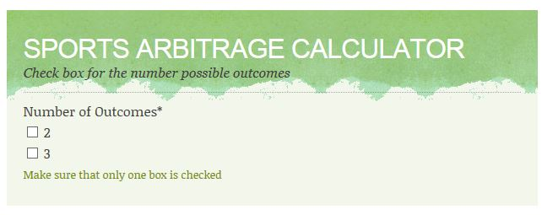
As there are just 2 possible outcomes in a tennis match, you should check the box marked “2”.
Once you have done that, put the amount that you want to invest, and the odds of your arbitrage bets.

Your odds should be input in decimals.

Most sites have a link for a display in decimals. If you want to convert a fraction to a decimal, just add 1. Therefore, 2/5 is 0.4. In decimals, this is 1 + 0.4 = 1.4. Similarly, 3-1 in decimals is 4.

The calculator will automatically, let you know how much to bet on each selection and your return on investment.
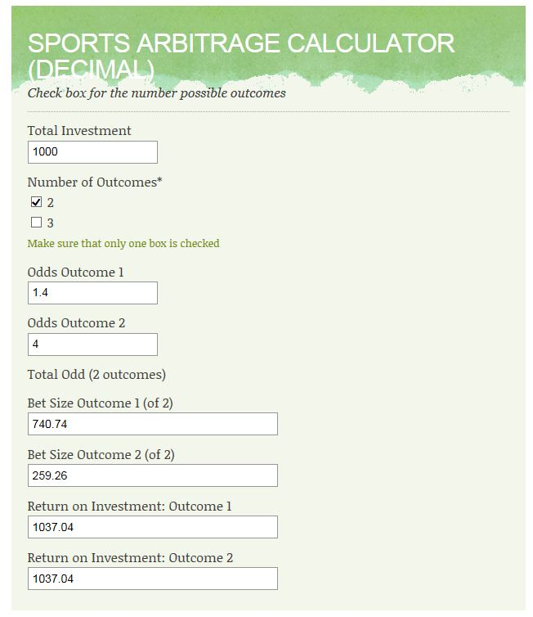

Most arbitrage bets are on football when there are 3 outcomes. You can get a result for either side. In addition, the match can be drawn. Therefore, there are 3 possible outcomes. In this case, you should check the box with 3 outcomes. You can also find arbitrage bets on cricket, basketball and American football.

In practice, finding arbitrage bets yourself is time-consuming. There is automated software around. Rebel Betting is one of the better known organizations for providing Sports Arbitrage Software.

If you want to know more about Sports Arbitrage, you should get a free ebook from Rebel Betting. You will find a link on the Casino Octopus website.

Comment
If you are considering sports arbitrage, you need a reasonable sized bankroll. Although the margins may seem thin, you need to realise the winning margins are often thin in any form of gambling. Even casinos, are satisfied with a guaranteed 0.5-1% win rate in some games. As mentioned, you are getting a much better win rate compared to sticking your money in a bank.

You can get better margins in skill games, such as poker, 3-card brag and backgammon. You have to find a player significantly weaker than you to get these margins.

However, sports arbitrage is basically a number-crunching exercise. There isn’t a great deal of skill involved. Therefore, you can’t expect the same margins as you would expect to get if you were a skilled poker player.

Sports arbitrage does have some risks. For example, the odds can change in between bets. It won’t happen often. However, it can happen. In addition, the bookmakers make errors sometimes. For example, they might have odds that were supposed to be 1/3. Instead, they have put them at 3/1. If they have made an error, most bookmakers give themselves the luxury of cancelling the bet. These errors are called “palpable errors” or “palps”. They are avoidable to a large extent with software. In addition, if the odds looks obviously too good to be true, you should probably assume it is a palp.

If you are just arbing or a matched betting to obtain funding for your blackjack game, you have an advantage

Players who do sports arbitrage for a living have to take measures to avoid getting identified as “arbers”. For example, they round their bets to whole numbers. They accept a small reduction in their winnings in order to avoid getting identified as a professional gambler. It isn’t that difficult but it is a bit of a hassle. If they get identified as an arber, they don’t lose their bet. They are usually told by the bookmaker that, in the future, they are not allowed to bet more than a small sum, such as $5, on football. Remember, they have access to over 100 bookmakers. Therefore, one bookmaker refusing large bets is not a big deal.

As a blackjack player, you will place your arb or matched bet. When you win, you will use the funds to play blackjack. There is no way the bookmaker or casino will be able to identify you as an arber or matched bettor. You will just appear as a general gambler who put a bet on a football match and then decided that you would like to play blackjack.

If you want more expert information of arbitrage betting, you should get the Rebel Betting ebook. There is a link on our website. The ebook is free and they tell you everything you need to know. They explain sports arbitrage in a lot of detail. In addition, they tell you the pros and the cons about arbitrage betting.

Chapter 9 Conclusions
Professional gambling should be seen as an investment. There are loopholes, such as matched betting and sports arbitrage. These are gambling systems that aren’t really gambling because you can win money simply because you can put the maths in your favour.

When it comes to skills games, you have to put the work in and read the right stuff. By becoming more skilled than your opponents or the casino, you can put the odds in your favour. If you are going to start playing a new game, you should just choose one game and develop your skills in that game. You can’t learn a lot of games at the same time. Once you have learnt a game well, you can move onto another game.

The main points are that
  - You should find a casino that doesn’t shuffle the deck after each hand
  - You should use the basic strategy with card-counting or the staking system discussed in this book
  - You should not go for the blackjack bonuses but instead, register through the sportsbook site and claim the sportsbook welcome bonus
  - You should use matched betting or sports arbitrage to get yourself a bankroll to fund your blackjack

At Casino Octopus, we are adding new strategy high quality articles on a regular basis. This is good place to start if you are aiming to develop your gambling skills.

You will also find the best casino bonuses on the Casino Octopus site. We only recommend cashable bonuses.

All the best at the tables
Kind Regards
Gary Free

http://www.casinooctopus.com
© Casino Octopus 2015 All Rights Reserved

